Alison Reikher

IST 707

3/19/2022

YouTube Dislikes Report

Introduction

On December 13th, 2021, YouTube announced that they will be removing the public dislike count for all YouTube videos (An update to dislikes on YouTube, 2021). While the dislike button will remain, only the creator can see the dislike count on their backend. The goal for this update was to prevent mass dislike campaigns against any creator as this is seen as bullying and harassment videos (An update to dislikes on YouTube, 2021). This decision caused a lot of backlash from the YouTube community. Many felt like the dislike button is a useful measure of how other viewers felt about the video. For instance, if a video was a tutorial, the dislike button was a good measure of how good the tutorial is. Despite the negative response, YouTube went forward with its decision and removed the dislike count.

Before this update, Kaggle user Dmytro Nikolaiev used an API to collect all the relevant data related to YouTube videos on the YouTube trending page. The YouTube trending page is a tab on YouTube that contains all the videos that are considered trending by several criteria. There are many ways for a video to appear on the trending page. Some of these ways included getting a significant number of views in a short period, the link to the video getting clicks from outside pages such as Facebook and Twitter, and a video being handpicked to appear on the Trending Page (Trending on YouTube - YouTube Help, n.d.). There is no exact science as to why a video might appear on the trending page. Often, it all comes down to the algorithm which is not public information.

The goal of analyzing these videos from the Trending page is to understand why people have disliked videos in the past and to look for any patterns to explain possible other user behavior. It is also to help answer the question: should YouTube bring back the dislikes count?

Analysis

The Data

The data used in this Analysis comes from the Kaggle dataset called YouTube Dislikes Dataset Collection which can be found here: <https://www.kaggle.com/dmitrynikolaev/youtube-dislikes-dataset-collection/data>. The dataset came with 2 unnecessary columns called Unique video ID and Channel ID. There is nothing interesting that can be done with these IDs, so these columns were removed from the dataframe.

The dataset is very large, so it was important to check for any NAs in the data and remove them. After omitting the NA values, the number of videos dropped from 37,422 rows to 37,264 rows.

Before:

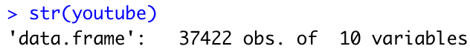

After:

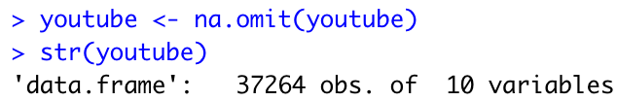

After the data has been cleaned, each variable can be further explored. The dataset consists of YouTube videos collected between August 2020 and December 2021. The videos come from the YouTube trending page from The United States, Canada, and Great Britain. It is important to note the location from where these videos were pulled since multiple languages are spoken in these countries. This will become more relevant later in the analysis.

The cleaned dataset consists of 37,264 rows. Each row consists of the relevant information related to the YouTube video. There are 10 columns in this dataframe. The title, channel title, published date, tags, description, and comments are all character data and therefore cannot be represented in a plot as is. The numeric data are the view count, likes, dislikes, and comment count. Each of these numeric values has a wide range. The view count ranges from 20,370 views to 1,323,000,000 views with the average falling at around 5,711,000 views. The likes range from 22 likes to 31,837,675 likes with an average of 167,287 likes. The dislikes range from 3 dislikes to 2,397,733 dislikes with an average of 4,996.4 dislikes. The comment count ranges from 1 comment to 16,071,029 comments with an average of 9,967 comments.

Exploratory Data Analysis (EDA)

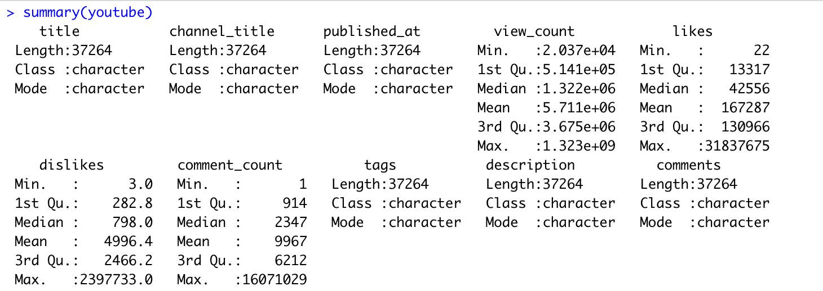Figure 1

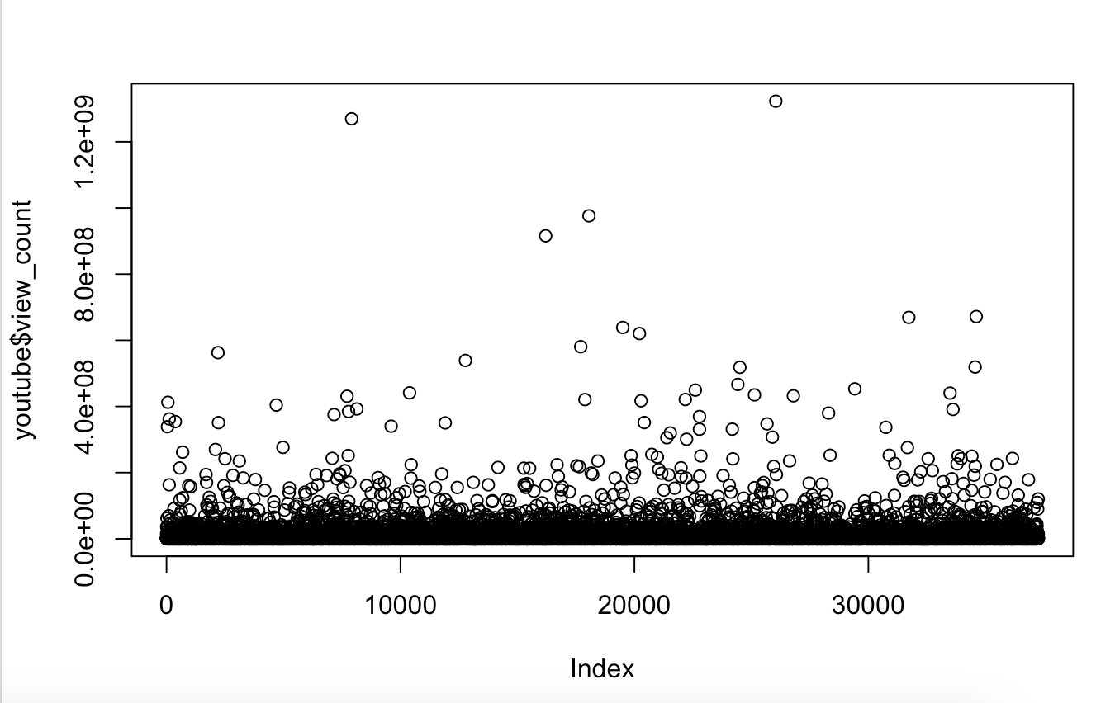Figure 2

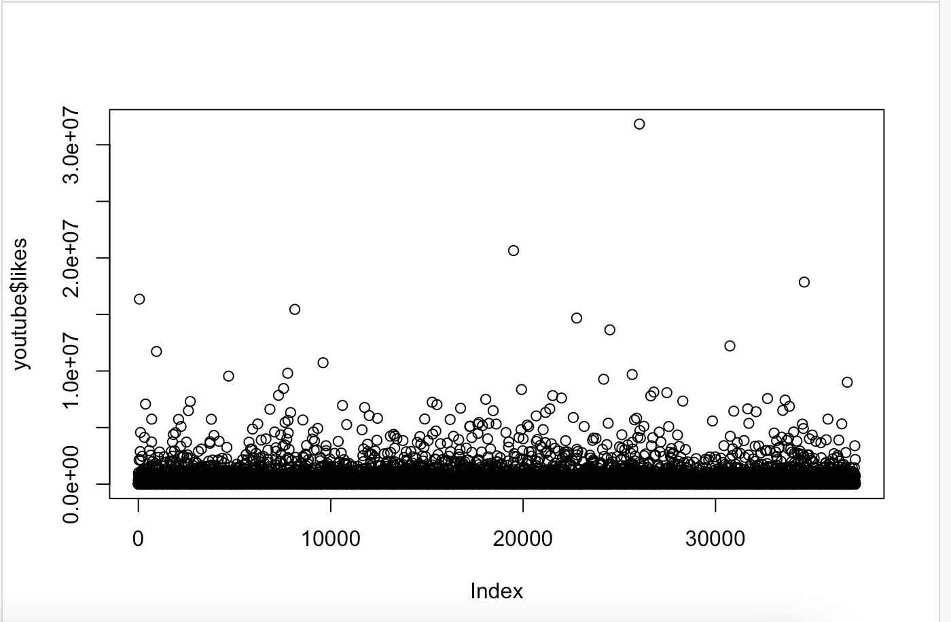Figure 3

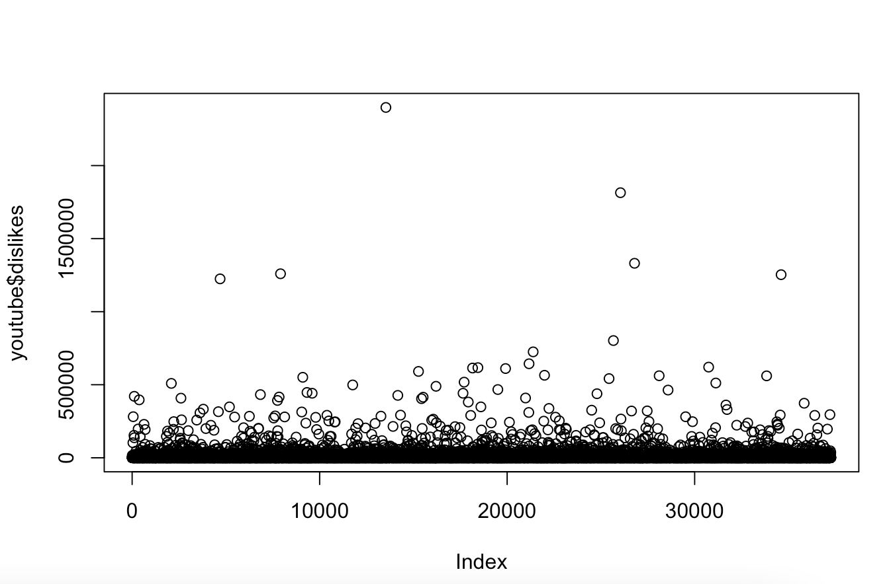Figure 4

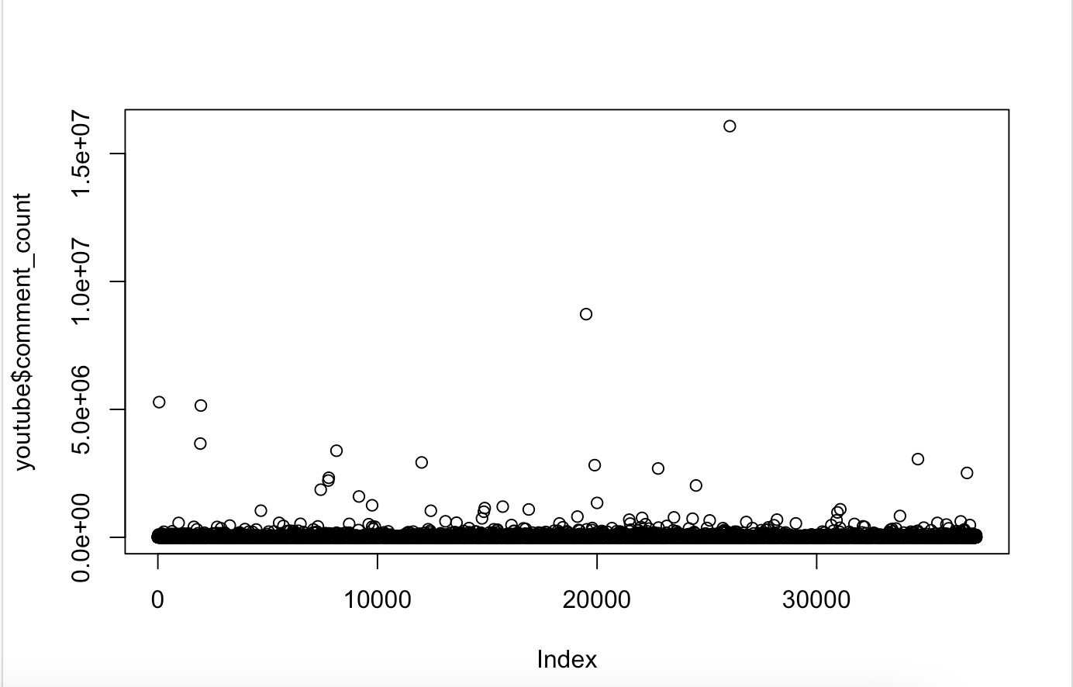Figure 5

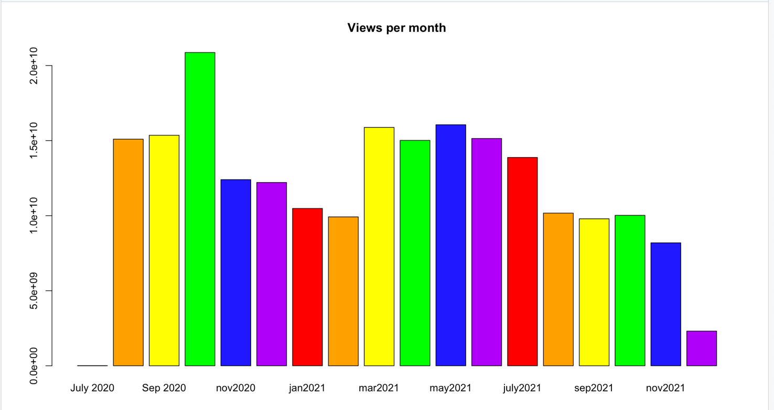Figure 6

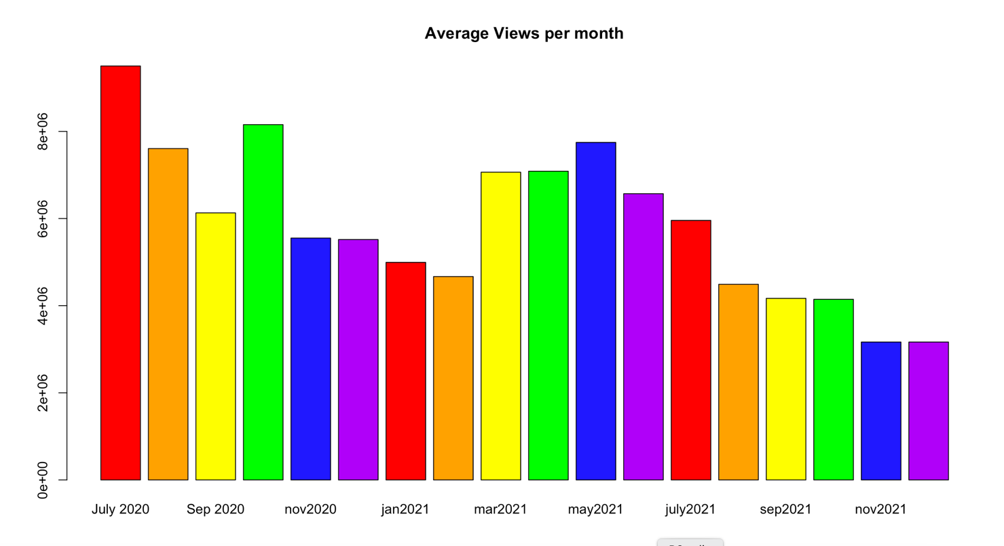Figure 7

Figure 1 is the summary breakdown of all the columns in the dataframe. Figures 2 through 5 are plots of view count, likes, dislikes, and comment count by index. Each figure suggests that there are outlier values within the data. However, there are too many values well above the 3rd quantile to know exactly how to handle the outliers. For this dataset, it is important to consider the obscenely high values since they give insight into YouTube user behaviors.

From Figure 2, the majority of the views fall below 20,000,000 views. There are still many videos with more than 20,000,000 views. When the top two most viewed videos are removed from this dataset, the average goes from 5,710,821 views to 5,641,556 views.

Figure 3 is a plot of all the likes by index. The majority of the like count falls below 10,000,000 likes. If the top 10 most liked videos were removed from the count, the average number of views would fall from 167,286.7 likes to 162,898.2 likes.

Figure 4 plots all the dislikes by index. Most of the dislikes fall below 1,000,000 dislikes. If the values greater than 1,000,000 dislikes are removed, the average would fall from 4,996.434 dislikes to 4,748.151 dislikes.

Figure 5 shows the plot for the comment count by index. This plot shows most clearly that the majority of the values fall below 5,000,000 comments. If the ones greater than 5,000,000 are removed, the average falls from 9,966.953 comments to 9,022.5 comments.

Figures 6 and 7 show the total and average views by month and year. Figure 6 demonstrates that October 2020, March 2021, and May 2021 had the most views. July 2020, February 2021, and December 2021 had the least views. It is important to note that there was only one video collected from July 2020 and only half of the videos from December 2021 were collected. Figure 7 shows that July 2020, October 2020, and May 2021 had the most average views. The months with the least average views are February 2021, November 2021, and December 2021. It is important to keep in mind that July 2020 only has one video that was collected so the average will be highest compared to the rest of the months. It is interesting to note that even when the views were averaged out, December 2021 still received significantly less than other months. November 2021 is a surprising month to have low views. Since November is a big holiday shopping month, it would be expected for more videos to be posted since more ads than usual will be on YouTube.

Other General Facts:

* Most viewed video: BTS () 'Dynamite' Official MV
* Most liked video: BTS () 'Dynamite' Official MV
* Most disliked video: Cuties | Official Trailer | Netflix
* Most commented video: BTS () 'Dynamite' Official MV
* Most common channel: Sky Sports Football

Apriori Method

The first model used in this analysis is called Association Rule Mining. Association Rule Mining takes a set of transactions and finds rules that predict the occurrence of an item based on the occurrence of other items in the transaction. To evaluate these rules, the algorithm utilizes 3 metrics: Support, Confidence, and Lift. For the definition, assume A -> B. Support refers to how often items in A and items in B occur together relative to all transactions. Confidence refers to how often items in A and items in B occur together relative to transactions that contain A. Lift is a ratio of the support divided by the probability of A times the probability of B. If the Lift is equal to 1, then A and B are independent. If the Lift is greater than 1, then A and B are positively correlated. For this analysis, Lift greater than 1 will be considered since the goal is to look for associations. It is most ideal to have high Confidence and high Lift. This will lead to high Support as well. For this analysis, Association Rule Mining is used to find any interesting rule regarding all the variables within the data set. (Reikher, 2022, pg 6)

The dataframe needed to be prepped before the algorithm was run. A copy of the main dataframe was created called youtubeApr. In the dataframe, the values were factored and discretized to better fit the algorithm. Specifically, the numeric values were grouped in ranges. This helps with generalizing the values. Given the size and quantity of the numeric data, the model would not work since the range of numbers is so wide. It would be unlikely that a rule could be created from any single value so they must be grouped.

The following are the most interesting or strongest rules:

* {view_count=[2.55e+06,1.32e+09], dislikes=[1.63e+03,2.4e+06], comment_count= [4.38e+03,1.61e+07]} => {likes=[8.78e+04,3.18e+07]}
  + Support: 0.1917400, Confidence: 0.9379102, Lift: 2.813580
* {channel_title=Sky Sports Football} => {likes=[22,2e+04)}
  + Support: 0.01199549, Confidence: 0.8386492, Lift: 2.516218
* {channel_title=Sky Sports Football} => {dislikes=[3,404)}
  + Support: 0.01148562, Confidence: 0.8030019, Lift: 2.412956
* {dislikes=[3,404)} => {view_count=[2.04e+04,7.11e+05)}
  + Support: 0.2612441, Confidence: 0.7850173, Lift: 2.355115
* {dislikes=[3,404)} => {likes=[22,2e+04)}
  + Support: 0.2484704, Confidence: 0.7466333, Lift: 2.240140
* {dislikes=[3,404)} => {comment_count=[1,1.29e+03)}
  + Support: 0.2352941, Confidence: 0.7070398, Lift: 2.121518
* {dislikes=[1.63e+03,2.4e+06]} => {view_count=[2.55e+06,1.32e+09]}
  + Support: 0.2671211, Confidence: 0.8011268, Lift: 2.403251
* {dislikes=[1.63e+03,2.4e+06]} => {likes=[8.78e+04,3.18e+07]}
  + Support: 0.2571919, Confidence: 0.7713481, Lift: 2.313920
* {dislikes=[1.63e+03,2.4e+06]} => {comment_count=[4.38e+03,1.61e+07]}
  + Support: 0.2346769, Confidence: 0.7038229, Lift: 2.111355
* {likes=[22,2e+04)} => {view_count=[2.04e+04,7.11e+05)}
  + Support: 0.2544279, Confidence: 0.7633655, Lift: 2.290158
* {likes=[22,2e+04)} => {dislikes=[3,404)}
  + Support: 0.2484704, Confidence: 0.7454911, Lift: 2.240140
* {likes=[22,2e+04)} => {comment_count=[1,1.29e+03)}
  + Support: 0.2407686, Confidence: 0.7223833, Lift: 2.167557
* {likes=[8.78e+04,3.18e+07]} => {view_count=[2.55e+06,1.32e+09]}
  + Support: 0.2668527, Confidence: 0.8005152, Lift: 2.401417
* {likes=[8.78e+04,3.18e+07]} => {dislikes=[1.63e+03,2.4e+06]}
  + Support: 0.2571919, Confidence: 0.7715344, Lift: 2.313920
* {likes=[8.78e+04,3.18e+07]} => {comment_count=[4.38e+03,1.61e+07]}
  + Support: 0.2542400, Confidence: 0.7626791, Lift: 2.287915
* {view_count=[2.04e+04,7.11e+05)} => {dislikes=[3,404)}
  + Support: 0.2612441, Confidence: 0.7837533, Lift: 2.355115
* {view_count=[2.04e+04,7.11e+05)} => {likes=[22,2e+04)}
  + Support: 0.2544279, Confidence: 0.7633041, Lift: 2.290158
* {view_count=[2.04e+04,7.11e+05)} => {comment_count=[1,1.29e+03)}
  + Support: 0.2338987, Confidence: 0.7017148, Lift: 2.105540
* {view_count=[2.55e+06,1.32e+09]} => {dislikes=[1.63e+03,2.4e+06]}
  + Support: 0.2671211, Confidence: 0.8013202, Lift: 2.403251
* {view_count=[2.55e+06,1.32e+09]} => {likes=[8.78e+04,3.18e+07]}
  + Support: 0.2668527, Confidence: 0.8005152, Lift: 2.401417
* {view_count=[2.55e+06,1.32e+09]} => {comment_count=[4.38e+03,1.61e+07]}
  + Support: 0.2357772, Confidence: 0.7072935, Lift: 2.121767

Sentiment Analysis

Sentiment Analysis is a machine learning model which assigns text data to a sentiment score to determine if the overall sentiment of the text is positive, negative, or neutral (Gupta, 2018). For this dataset, Sentiment Analysis was used to analyze the videos which had more dislikes than likes. These rows were put into a separate dataframe called dislikesDF. The original dataframe is too large for the model so a subset had to be extracted. Since the goal of this analysis is to better understand why users dislike certain videos, analyzing the videos that made it onto the Trending Page and still had a significant number of dislikes was worth exploring. If a video with a significant number of dislikes reaches the Trending Page, that implies there is something about the video that is deemed suitable for the Trending Page despite getting a negative response from the audience.

The algorithm starts by taking the column that sentiment should be performed on using the function called analyzeSentiment. For this analysis, the columns used for analysis were titles, comments, tags, and descriptions. This function produces a dataframe with all the sentiment scores. The score most relevant for this analysis is SentimentQDAP score. Based on the QDAP dictionary, it assigns the character value to a score that gives the overall sentiment. Then, the convertToDirection function converts the score to the keywords Positive, Negative, or Neutral. The results from this function are added back to the dislikesDF dataframe.

Additionally, a Term Document Matrix was created with the most frequent words and their frequency for the video titles, comments, tags, and descriptions. Comments have the most words among the four variables. The stop words were removed from the comments to better understand the root words. However, the word frequency list didn’t produce anything significant or interesting. Therefore, the stopwords will be left in and any interesting words from this list will be examined.

Correlation Analysis

The best way to conduct a Correlation Analysis is to create a correlation matrix. This can be done using the cor function. This function calculates the correlation coefficients between each variable and puts that information into a correlation matrix. This matrix can in turn be converted into a correlation heat map.

A correlation matrix was created for both the main YouTube dataframe and the dislikes dataframe. The columns examined were the views, likes, dislikes, and comment count. This is done to see if the relationship between the variables changes when the variables are isolated to a specific criterion. In this case, it is the variables with more dislikes than likes. This will show how videos with this type of criteria relate to the other variables.

Results

Results from Apriori Method

There were 20 rules found from the Apriori Method with various degrees of confidence. The rule with the highest level of confidence was {view_count=[2.55e+06,1.32e+09], dislikes=[1.63e+03,2.4e+06], comment_count= [4.38e+03,1.61e+07]} => {likes=[8.78e+04,3.18e+07]} with a confidence level of 0.9379102. What this rule says is that if a video gets between 2,550,000 and 1,320,000,000 views, 1,630 and 2,400,000 dislikes, and 4,380 and 16,100,000 comments, it will likely receive between 87,800 and 31,800,000 likes. While this rule is strong, it is very general. It is such a wide range that it accounts for a lot of the dataset.

The Apriori Method allows for certain rules to be set for both the right-hand and left-hand sides. The rule for channel_title ‘Sky Sports Football’ was that likes fall between 22 to 2,000 likes and dislikes fall between 3 to 404 dislikes. The Sky Sports Football channel is the most frequently occurring channel on the Trending page. The confidence for these rules was relatively strong with 0.8386492 and 0.8030019 respectively. This rule could help the owners of this channel with what to expect for likes and dislikes for any given video.

When dislikes fall between 3 and 404 dislikes, the lower end of the dislikes range, the view count falls between 20,400 and 711,000 views with confidence of 0.7850173. The likes fall between 22 and 20,000 likes with a confidence of 0.7466333. The comments will fall between 1 and 1,290 comments with a confidence of 0.7070398. All these rules vary in confidence with the view count being the most confident. On the other hand, when dislikes fall between 1,630 and 2,400,000, the view count falls between 2,550,000 and 1,320,000,000 views with a confidence of 0.8011268. The likes fall between 87,800 and 31,800,000 likes with a confidence of 0.7713481. The comments will fall between 4,380 and 16,100,000 comments with a confidence of 0.7038229. As the lower end of the dislikes range, the confidence is fairly high but leaves room for error. The strongest confidence among all the rules involving the higher range dislike and view count. Similar to other rules, this range is broad and nothing definitive can be concluded. However, it is fair to say that videos with higher view counts can expect higher ranges of dislikes than videos with fewer views.

The lower range for the likes falls between 22 and 20,000 likes. For this range, view count tends to fall between 20,400 and 711,000 views with confidence of 0.7633655. Comment count tends to fall between 1 and 1,290 comments with confidence of 0.7223833. Dislikes were already discussed previously. In the higher range, the likes fall between 87,800 and 31,800,000 likes. For this range, view counts fall between 2,550,000 and 1,320,000,000 views with a confidence of 0.8005152. Comment counts fall between 4,380 and 16,100,000 comments with a confidence of 0.7626791. The highest confidence among all the rules is for view counts on the higher range of likes. This rule is intuitive because if more people watch a video, the more likely they will press like.

The final range is for view count. The only rule left to cover is the rules that apply to view count and comment count. The view count in the lower range falls between 20,400 and 711,000 views. The comment count range falls between 1 and 1,290 comments with confidence of 0.7017148. The higher range for view count falls between 2,550,000 and 1,320,000,000 views. The comment count range falls between 4,380 and 16,100,000 comments with confidence of 0.7072935. While both confidences are on the higher side, both are less than the confidence between view count and likes and dislikes. As stated above, there is a clear relationship between the number of views and like and dislike counts. As the number of views increases, the number of likes and dislikes increases.

The biggest limitation of this method is that it is too general for this dataset. While some rules do give some insight, for the most part, the ranges are just too big to be meaningful.

Results for Sentiment Analysis

For the comments, descriptions, tags, and titles for videos in the dislikesDF dataframe, the sentiment score was converted to either Positive, Neutral, or Negative.

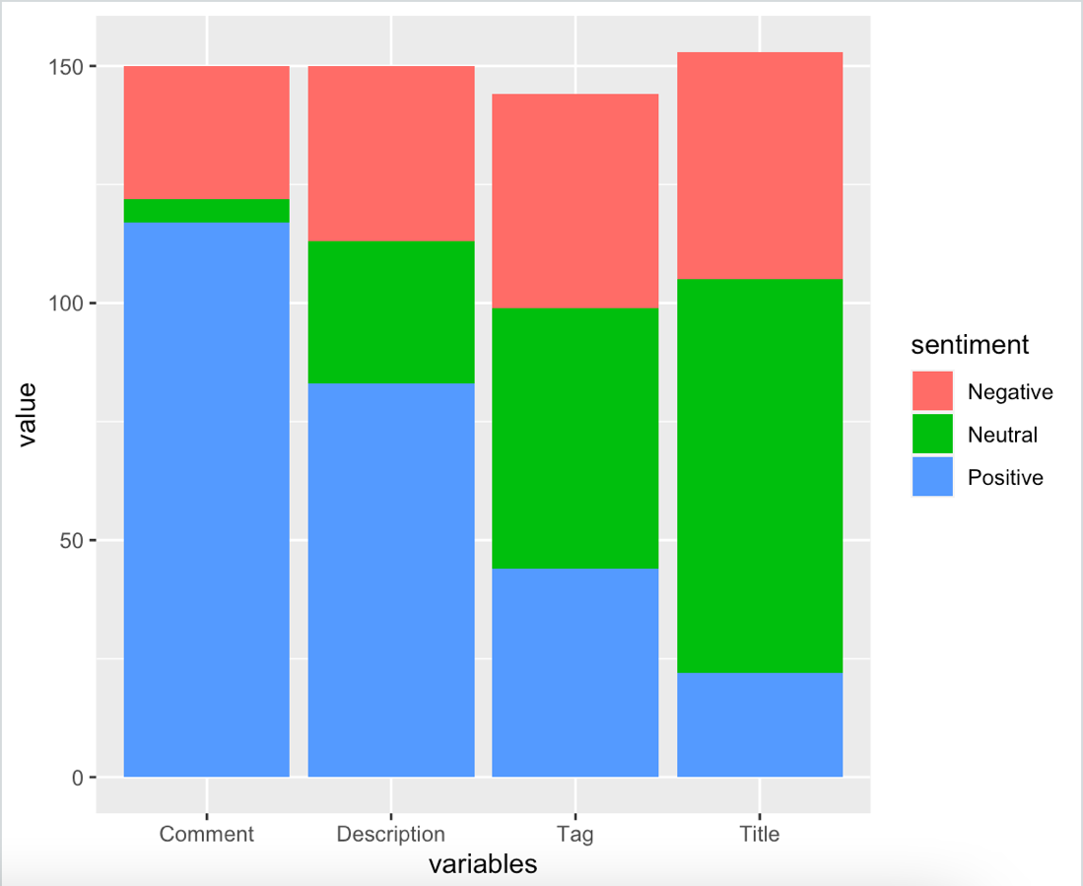

Figure 8

Figure 8 graphically shows via stacked barplot the various number of Positive, Neutral, and Negative sentiment scores within the dataframe.

Comments had the most Positive sentiment with 117 Positive comments. There are also 5 Neutral comments and 28 Negative comments. Comments are to be expected to have more Positive than Negative sentiment. Comments can be easily manipulated by the video owner to ban certain words or phrases. Comments can also be deleted by the owner.

Descriptions had the next highest Positive sentiment with 83 Positive descriptions. There are also 30 Neutral descriptions and 37 Negative descriptions. The description is entirely written by the content creator so the sentiment would solely reflect the subject matter. The creator would most likely want their descriptions to be positive or neutral depending on the video. Given that many of the videos are news videos, it is unavoidable for there to be negative sentiment.

Tags had the second-lowest Positive sentiment with 44 Positive tags. There are also 55 Neutral tags and 45 Negative tags. Unlike the previous two, tags as a higher number of both Neutral and Negative tags. Since tags often don’t contain words that give emotion, they are analyzed purely on keywords. Since many of the videos involved Covid, a lot of the keywords would involve words like virus and pandemic which would result in a Negative sentiment score.

Title had the least amount of Positive sentiment and the highest amount of Negative and Neutral sentiment. There are 22 Positive titles, 83 Neutral titles, and 48 Negative titles. Understandably, titles would most likely have the most Neutral sentiment compared to the other variables. Creators might not want something more neutral to get more clicks. However, there is something to note about these videos still having more Negative sentiment. It is in part due to several major events in the past two years and the media coverage about them.

The videos with Negative sentiment for all four variables were titled "Warzone INVISIBLE GLITCH! INVISIBLE GLITCH WARZONE! Warzone Season 1", “"\"FURY BE A MAN!\" DEONTAY WILDER FINALLY BREAKS SILENCE! ACCUSES TYSON FURY OF CHEATING IN 2 FIGHTS"”, "Opposing crowds protest outside Wisconsin courthouse awaiting Kyle Rittenhouse trial verdict", and "Covid : le Royaume-Uni de plus en plus isol et au bord du chaos". The first video is from a video game involving war. The algorithm picked up various keywords related to this and considered it negative. However, just because it is a video game does not necessarily indicate there is something negative about the video. The only clear negative is that it involves war. The algorithm cannot pick up this nuance and understand it is a video game rather than an actual negative event. The second video is about a fight. There is some negativity surrounding the fight based on the title. It makes sense for there to be negativity picked up from that. It also suggests that the comments and other variables would most likely lean more on the negative side. The third video was a big news story of last year. The result of this verdict was very polarizing so, surprisingly, the sentiment for all four variables is negative. The last one translates to “Covid: the United Kingdom increasingly isolated and on the verge of chaos”. Given that Covid is often associated with keywords like virus and pandemic, it makes sense for a negative sentiment along with the use of words like isolated and chaos.

With Sentiment Analysis, it is important to understand what words appear most frequently to better understand why the sentiment produced the results that it did.

|  |  |
| --- | --- |
| Figure 9 | Figure 10 |
| Figure 11 | Figure 12 |

Figures 9 through 12 are the most frequently used words in the video title, channel name, comment, and tags columns in the dislikesDF dataframe. From the titles in Figure 9, the clear topic most often disliked revolves around Covid. Covid has dominated the news over the past two years so this is to be expected. The next most frequent keyword is Boris Johnson. For whatever reason, no other world leader showed up in the dislikesDF dataframe. The other most frequent word is news. This shows that people are disliking certain news worth events rather than the quality of the video itself.

Figure 10 shows all the channel names. As expected, the most frequent words are news or specific news channels. This suggests that these networks are sharing clips and videos of various newsworthy events that people respond negatively towards.

Figure 11 are all the comment keywords. When the stopwords were removed from the vector list, the results weren’t particularly interesting. No word stood out when doing so. While this list still has stopwords, the most interesting word is people. This indicates that communities value people and discuss the effects of the news as it relates to people.

Figure 12 are all the tag keywords. Tags were more informative since they are like descriptions but without the stopwords. News and Covid were the clear standouts from this list. This is to be expected from the previous lists. Boris Johnson appears here as well. This most likely correlates to the titles his name was included in. The most interesting keyword that’s completely different from others in previous lists is Djokovic. Djokovic is the name of a famous tennis player. He most likely did something newsworthy that made him appear on this list but not necessarily as big as the other topics on the other lists.

Sentiment Analysis is not perfect. There are some limitations when it comes to using it on this dataset. The biggest limitation is it doesn’t perfectly know how to handle characters in other languages. The algorithm was not designed to perfectly understand languages other than English. In addition, there is no clean way to remove all the data that isn’t in English from the dataframe. R provides a few methods, but none were good enough for this report. Another limitation is that Sentiment Analysis doesn’t always understand sarcasm or words and phrases that are used in multiple contexts. Sometimes something could read as positive, but the result is supposed to be negative and vice versa. Like in the Warzone example, the algorithm couldn’t have picked up on the fact it was a video game to determine the sentiment doesn’t necessarily need to be negative.

Results from Correlation Analysis

For the Correlation Analysis, two correlation matrices and corresponding heat maps were produced.

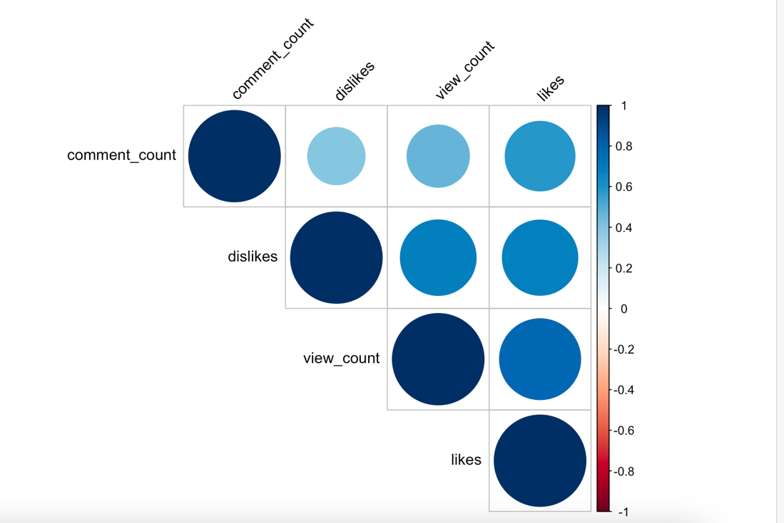

Figure 13

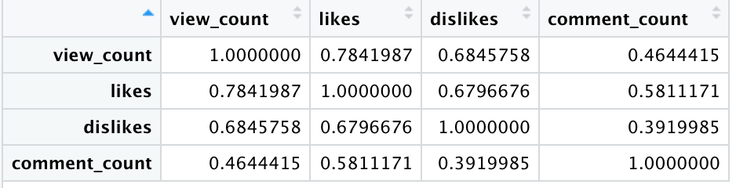

Figure 14

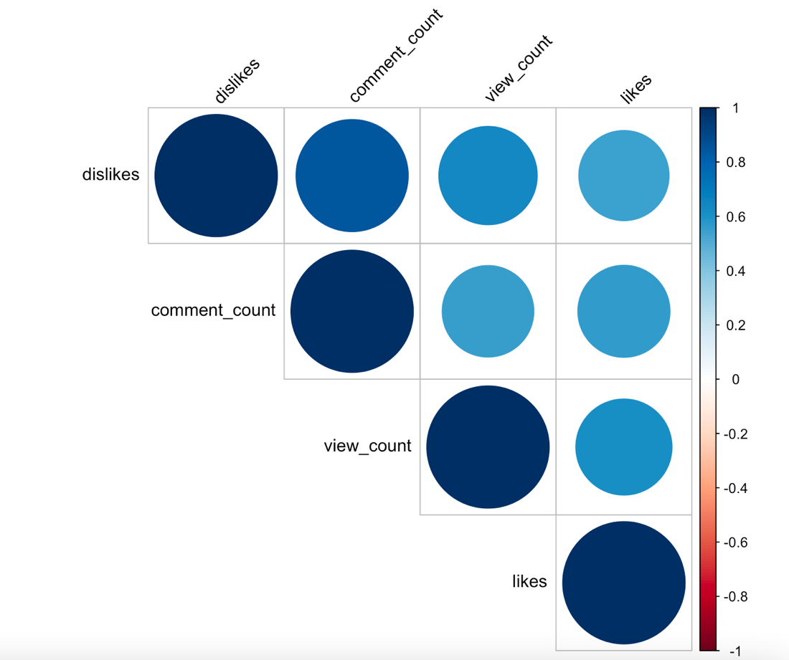

Figure 15

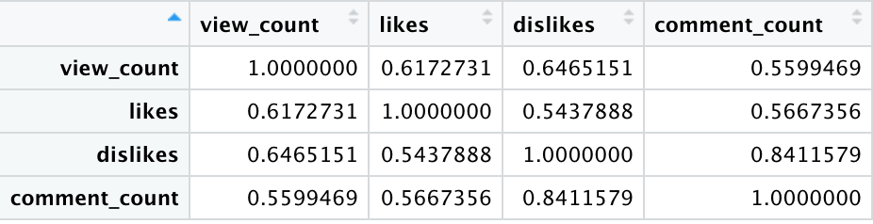

Figure 16

Figures 13 and 14 correspond to the youtube dataframe for the whole dataset and Figures 15 and 16 correspond with the dislikesDF dataframe.

For the youtube dataframe, there is only one significant correlation. The correlation coefficient between view count and likes is 0.7841987. This indicates that as the number of views increases, the more likes the video receives. The two variables with the least strong correlation coefficient are between dislikes and comment count with correlation 0.3919985. The rest of the correlation coefficients are less than 0.7 so no definitive conclusions can be drawn.

For the dislikes dataframe, there again is only one significant correlation. Interestingly enough, this correlation is between dislikes and comment count with a correlation coefficient of 0.8411579. In the previous matrix, this correlation coefficient was the weakest correlation. For the context of this dataframe, what this means is that as the dislikes increase, the number of comments increases. If a video is already considered more disliked than liked, users will more likely want to comment their opinion on the video. The rest of the correlations are less than 0.7 and are not significant.

The limitation of correlation analysis is that it only applies to numerical data. A lot of the data in this dataset was character data. To find any correlation with these data points, they would need to be converted into a numeric value in some meaningful way. Given the size of the dataset, it would take more time to determine what the most meaningful way would be. Often, it is not intuitive since there is a large variety of genres.

Conclusion

While the dislikes are no longer displayed on YouTube, there is still a lot to learn from previously collected data. Apriori Method showed that as the number of views increases, the number of likes and dislikes also increase. Sentiment Analysis showed that the most disliked videos were news stories. The title and tags for these videos will tend to be more negative and neutral while the description and comments of these videos will tend to be more positive. Comments will most likely always come up more positive than negative since comments can be filtered or banned based on certain words. The correlation matrices suggest that as the number of views increases, the number of likes increases. This is similar to the findings from the Apriori Method. However, when videos are isolated by being more disliked than liked, as the number of dislikes increases, the number of comments increases. This shows that users become more engaged in the content with they feel strongly enough about the video to press the dislike button.

The underlying question in all this is should YouTube return the dislike count? Some users would say yes while others might say no. From this analysis, it can be extrapolated what the dislikes could be for any given video. If the video has more likes and views, it most likely has proportionally as many dislikes. If a video is about something upsetting going on in the news or the world, it will most likely have more dislikes than the likes displayed. However, not seeing the dislike count might suppress users’ desires to press the dislike button.

In conclusion, the use of the dislikes button is a reflection of the YouTube user base. While it is often used to demonstrate a dislike for a particular video, it also comes with the territory with an increased number of engagements. The more people watch and engage with the content, the more people will like or dislike it. This is neither good nor bad. This is simply part of the YouTube ecosystem that is ever-changing.

Work Cited

blog.youtube. 2021. An update to dislikes on YouTube. [online] Available at

<https://blog.youtube/news-and-events/update-to-youtube/> [Accessed 13 February

2022].

Reikher, A. (2022). *Homework 3 IST 707* [Unpublished report]. Syracuse University.

Gupta, S. (2018, January 19). *Sentiment analysis: Concept, analysis and applications*. Medium. Retrieved March 17, 2022, from https://towardsdatascience.com/sentiment-analysis-concept-analysis-and-applications-6c94d6f58c17

Support.google.com. n.d. *Trending on YouTube - YouTube Help*. [online] Available at

<https://support.google.com/youtube/answer/7239739?hl=en> [Accessed 13 February

2022].